**Varendra University**

**Department of Computer Science and Engineering**

5th Semester

**Course Code:** CSE 226

**Course Title:** Algorithm Lab

**Lab Quiz**

**Time:** 35 minutes  **Marks:** 20

**Name: ID:**

|  |  |  |  |  |  |
| --- | --- | --- | --- | --- | --- |
| 1. | Algorithm course is fun isn’t it? | | 7. | What is the best case time complexity for Bubble sort? | |
| a) True | b) False | a) N 2 | b) N (log N) 2 |
| c) No Comment | d) Both | c) N log N | d) N |
| 2. | Which of the following sorting algorithm gives best performance when the input array is almost sorted? | | 8. | How many number of comparisons are required in insertion sort to sort a file if the file is sorted in reverse order. | |
| a) Heap Sort | b) Quick Sort | a) N2 | b) N/2 |
| c) Merge Sort | d) Insertion Sort | c) N | d) N-1 |
| 3. | ______ turns out that one can find the shortest paths from a given source to all points in a graph in the same time. | | 9. | Which of the following standard algorithms is not a greedy algorithm? | |
| a)Kruskal's algorithm | b)Bellman ford algorithm | a) Dijkstra Shortest path algorithm | b) Kruskal Algorithm |
| c) Prim's algorithm | d) Dijkstra's algorithm | c) Prim's Algorithm | d) Bellman Ford Shortest Path Algorithm |
| 4. | Consider a situation where swap operation is very costly. Which of the following sorting algorithms should be preferred so that the number of swap operations is minimized in general? | | 10. | What is the time complexity of fun()?  int fun(int n)  {  int count = 0;  for (int i = 0; i < n; i++)  for (int j = i; j > 0; j--)  count = count + 1;  return count;  } | |
| a) Insertion Sort | b) Bubble Sort | a) Theta (n) | b) Theta(n^2) |
| c) Selection Sort | d) Merge Sort | c) Theta (n*Logn) | d) Theta (nLognLogn) |
| 5. | What is the worst case time complexity of linear search algorithm? | | 11. | Dijkstra Algorithm is also called the ____ shortest path problem. | |
| a) O(1) | b) O(n) | a) single source | b) multiple source |
| c)O(n2) | d) O(log n) | c) single destination | d) multiple destination |
| 6. | Which of the following sorting procedure is the slowest? | | 12. | Which of the following case does not exist in complexity theory? | |
| a) Quick Sort | b) Heap Sort | a) Best Case | b) Worst Case |
| c) Merge Sort | d) Bubble Sort | c) Null Case | d) Average Case |
| 13. | Which of the following data structure is linear data sturcture? | | 16. | Finding the location of the element with a given value is known as - | |
| a) Trees | b) Arrays | a) Traversal | b) Search |
| c) Graphs | d) None of Above | c) Sort | d) None of the above |
| 14. | Two main measures for the efficiency of an algorithm are - | | 17. | Which of the following sorting algorithm has the lowest worst case complexity? | |
| a) Processor and memory | b) Time and Space | a) Bubble Sort | b) Quick Sort |
| c) Complexity and capacity | d) Data and Space | c) Merge Sort | d) Selection Sort |
| 15. | Let A1, A2, A3, and A4 be four matrices of dimensions 10 x 5, 5 x 20, 20 x 10, and 10 x 5, respectively. The minimum number of scalar multiplications required to find the product A1A2A3A4 using the basic matrix multiplication method is | | 18. | Consider the unidirectional graph below:  http://www.geeksforgeeks.org/wp-content/uploads/gq/2015/12/primsMST.png  Using kruskal's algorithm, construct a minimum spanning tree. Which one of the following sequences of edge represent a possible order in which the edges would be added to construct the minimum spanning tree? | |
| a) 1500 | b) 2000 | a) (A, D), (A, B), (A, C), (C, F), (G, E), (F, G) | b) (E, G), (C, F), (F, G), (A, D), (A, B), (A, C) |
| c) 500 | d) 100 | c) (A, D), (A, B), (D, F), (F, C), (F, G), (G, E) | d) (A, B), (A, D), (D, F), (F, G), (G, E), (F, C) |

**19.** You are given a knapsack that can carry a maximum weight of 60. There are 4 items with weights {20, 30, 40, 70} and values {70, 80, 90, 200}. What is the maximum value of the items you can carry using the 0/1 knapsack?

**Ans:**

**20.** What is the shortest path from node A to node F? 2

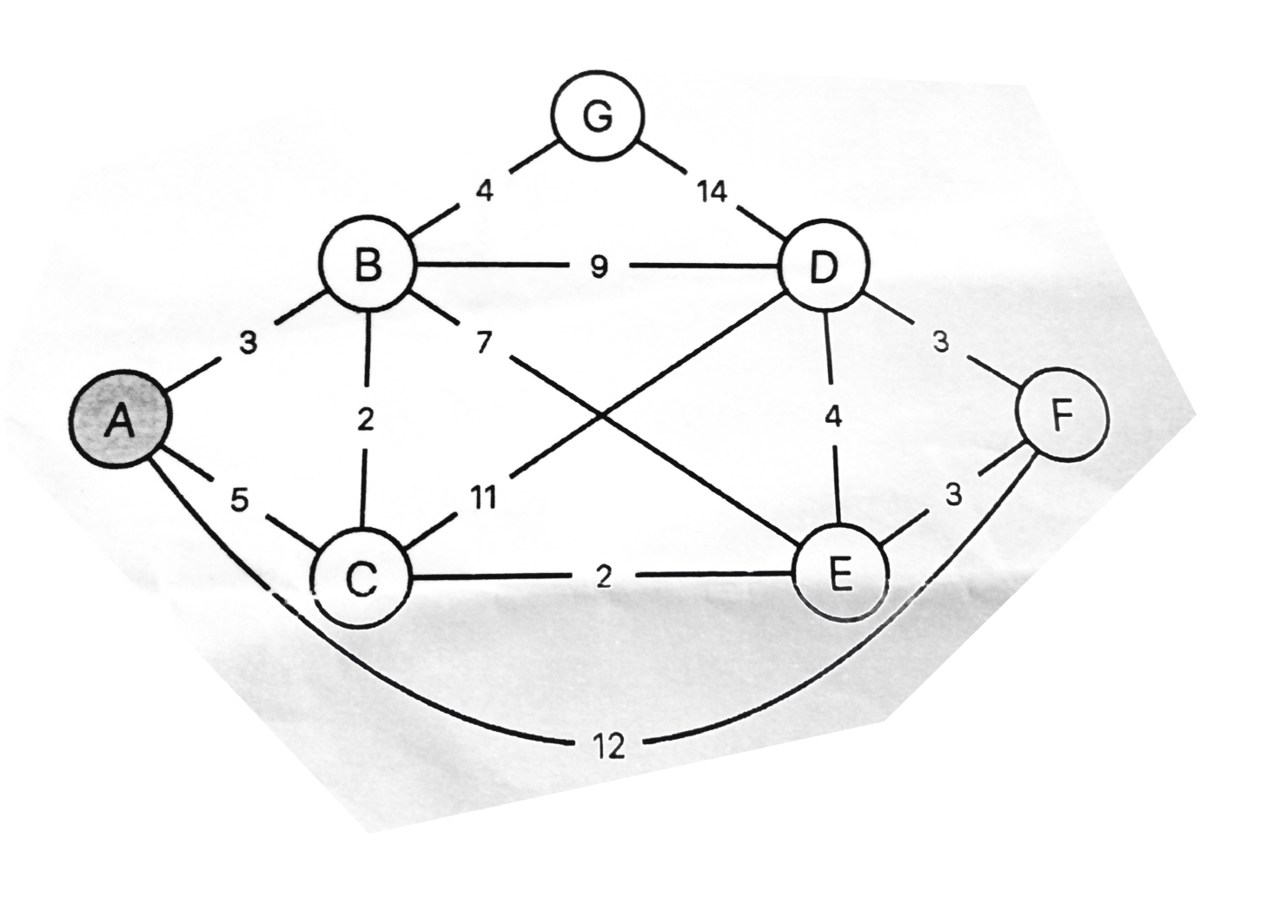

**Ans:**